**Software Engineering Challenge**

**Requirements**

Describe the challenge or problem, what does the program need to do?

To design an animated city with at least 4 buildings and windows, with at least one animation not using blinking windows

What classes/objects do you think you need?

I will need to know how to use the classes needed for animates

How much time do you think you will you need to complete the project?

Maybe 5 days

**Research**

What knowledge or skills will you need to build this program?

I need to know how to use animated and threads to flicker the windows and/or make the city more dynamic in general

What examples are online or in other graphical programs (games, apps etc. . .)

        If so, what can you learn from them?

I could perhaps learn from realm of the mad god in terms of using simple animation to make something appear moving

Do you foresee any problems or constraints, describe

The size of the applet window is the most obvious constraint, as well as the time I have

Have you created a similar programs or applets? Are there similar programs in the book or other resources?

Yes I can find the resources throughout the book, I have used applets in the past

If so, what elements of that project can you bring to this project?

I can use all of the elements above in the project

Do you have the resources you need to create the program?

Yes

Do you need to learn any new knowledge or skill(s) to create the program?

Not that I forsee, everything that I’ve been taught at this point involving threads and animation should be enough

**Design**

Draw/create a basic graphic of the applet you plan to build - attach the drawing

(paint, word, photoshop) not every objet (draw one example although there may be several in the final program) needs to be in the basic graphic

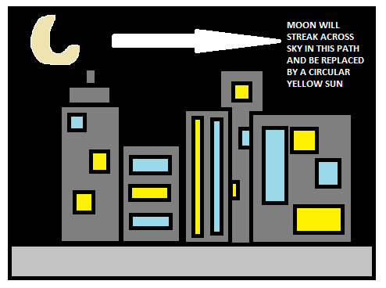

Include a task list--what will you need to do and in what order (INCLUDED AT BOTTOM)

Estimate the amount of time you will need to complete the project (5 days)

**Construction – included in summary doc**

Document your construction progress with date and progress made (build a chart/table in word or excel), also, include at least three screenshots of your applet (beginning, middle, and end)

Yes I will

**Testing/Results/Delivery—summary doc not required to start project**

Preliminary testing

Does your program meet the needs of the initial challenge or problem?  How do you know?

**Yes, I created a city with randomly blinking windows and one other animated, it looks like a dynamic cityscape which is how I know that my program meets the initial challenges.**

Are any changes or modifications needed, why or why not?

**No, because my project covered the requirements that were initially asked**

 Document any changes.

**Done Below**

Summarize the project - what worked, what didn’t work, note your successes and/or failures.

Looking back, would you have done anything differently, why or why not

**What Worked: getting everything to show up**

**What didn’t work: doing that efficiently, I ended up using a strategy that involved repainting the entire canvas, I would have used threads but that ended up not working because of how compact my program was.**

**Next time, I would have used many different classes in order to use threads efficiently so that my animation would look nicer and I could do more with it.**

Software Summary Document

Daily Progress Report

|  |  |
| --- | --- |
| Date | Description |
| January 14, 2018 | Made ground and methods for the buildings and added colors for the building and made the methods for the locations |
| Jan 15 18 | Got the buildings and ground to display properly along with the window method, refined the methods in the class to do one thing only |
| 1/16/2019 | I got the windows to display, repositioned and recolored the buildings, I got most of the visuals to display the only problem is that I have been unable to get the windows to blink for the moment as they seem to redraw but in the wrong color, plan on finishing blinking windows by tomorrow |
| 1/17/2019 | Created the clouds and got them to move across the screen, also changed the colors of the buildings and got the windows to blink randomly. Made sure that all of the windows in the buildings had the ability to blink randomly when the applet was executed, it covered the requirements. |
| 1/18/19 | Completed the project, refined the clouds and got them to move better as well as making the project as a whole more refined with documentation |

|  |  |
| --- | --- |
| Tasks | Completed? |
| Make the 5 buildings | Yes (1/14) |
| Make the sky and ground | Yes (1/14) |
| Include the sun | Yes (1/15) |
| Include the windows | Yes (1/16) |
| Make the windows blink | Yes (1/17) |
| Polish the project so that buildings don’t overlap unseemly | Yes (1/18) |
| Make sure that your project has all the requirements, including the two animations | Yes (1/18) |
| Comments in the code | Yes (across all days, finished 1/18) |
| Correct documentation in the code | Yes (1/18) |
|  |  |